Computer vision Techniques
Question Bank
Unit 1
Image Representation & Basics
- Explain how a grayscale image is represented mathematically. If an image uses 8-bit representation, calculate the total number of possible intensity levels.
- Compare grayscale and color image representation. How many values are stored per pixel in RGB format?
- Given an image function:
$$g(x,y)=T[f(x,y)]$$
Explain the meaning of each term with an example.
Answer:
1. Grayscale Image Representation
Mathematically, a grayscale image is represented as a two-dimensional discrete function f(x, y).
- Coordinates (x, y): These represent the spatial location of a pixel in the grid (row and column).
- Amplitude f: This is the intensity or brightness of the image at that specific point.
Calculating Intensity Levels
The number of possible intensity levels depends on the number of bits (k) used to represent each pixel.
- Formula: L = 2^k
- Calculation for 8-bit: 2^8 = 256 possible intensity levels.
- Range: These levels are typically represented as integers ranging from 0 (pure black) to 255 (pure white).

2. Grayscale vs. Color Image Representation
While grayscale images are 2D matrices, color images add a dimension of "depth" to account for different color channels.
Feature | Grayscale Image | Color Image (RGB)
Dimensions | 2D Matrix (M * N) | 3D Tensor (M*N * 3)
Values per Pixel | 1 value (Intensity) | 3 values (Red, Green, Blue)
Information | Only brightness information. | Brightness + Chromaticity (color).
In RGB format, each pixel stores a triplet of values [R, G, B]. For an 8-bit color image, each channel has 256 levels, meaning a single pixel can represent over 16.7 million (256 * 256 * 256) possible colors.

3. Explaining the Image Function: g(x, y) = T[f(x, y)]
This is the fundamental equation for Spatial Domain Processing. It describes how we transform an input image into a processed output image.
Term Definitions
- f(x, y): The Input Image. This is the original raw data you start with.
- g(x, y): The Output (Processed) Image. This is the result after the transformation is applied.
- T: The Transformation Operator. This is the "rule" or algorithm applied to the pixels. It can operate on a single pixel or a neighborhood of pixels.
Example: Image Brightening (Point Processing)
Suppose you want to make an image slightly brighter. You decide to add a constant value of 50 to every pixel.
- The Function: g(x, y) = f(x, y) + 50
- Meaning: If a pixel at location (10, 20) in the input image has an intensity of 100 (f(10, 20) = 100), the transformation T (adding 50) results in an output intensity of 150 for that same coordinate in g(x, y).
Example: Image Negative
For an 8-bit image, the transformation to create a negative is:
- The Function: g(x, y) = 255 - f(x, y)
- Meaning: Light areas (high values) become dark, and dark areas (low values) become light.

Point Processing & Intensity Transformations
- Perform image negation for the following pixel values assuming L = 256:
Input pixels: [20, 50, 100, 200]
- Explain log transformation and its application in enhancing dark images.
- For gamma transformation:
$$s=cr^{γ}$$Explain the effect of:
- γ < 1
- γ = 1
- γ > 1
Answer:
4. Image Negation (L = 256)
Image negation is calculated using the formula: s = (L - 1) - r, where r is the input pixel value.
For L = 256, the formula is s = 255 - r.
Input Pixel (r) | Negation Calculation (255−r) | Output Pixel (s)
20 | 255 - 20 | 235
50 | 255 - 50 | 205
100 | 255 - 100 | 155
200 | 255 - 200 | 55
5. Log Transformation
The formula is s = c . log(1 + r).
- Effect: It maps a narrow range of low-intensity (dark) input values into a wider range of output levels.
- Application: It is used for enhancing dark images or visualizing images with a high dynamic range, such as a Fourier Spectrum, where the intensity values can vary significantly. It "spreads out" the dark pixels so details hidden in shadows become visible.
6. Gamma Transformation (Power-Law)
The formula is s = c . r^gamma. The value of gamma (Gamma) determines the shape of the transformation curve:
- gamma < 1 (Encoding/Expansion): Similar to Log transformation. It "stretches" the lower intensity levels, making dark images brighter.
- gamma = 1 (Identity): The transformation is linear. The output is a direct mapping of the input (no change in brightness).
- gamma > 1 (Compression): It "compresses" the lower intensity levels and stretches the higher ones, making the image darker (useful for enhancing overexposed images).

Histogram & Enhancement
- Define histogram equalization. Why is it useful in low contrast images?
- Given pixel frequency:
Gray Level | Frequency
0 | 10
1 | 20
2 | 30
3 | 40

Calculate probability density function (PDF).

Answer:
7. Define Histogram Equalization
Histogram Equalization is a spatial domain technique that redistributes the intensity levels of an image so that the resulting histogram is uniform (flat).
- Usefulness in Low Contrast Images: In low-contrast images (where all pixels are clustered in one narrow color range, like all grays), the image looks "washed out." Equalization "stretches" this cluster across the entire range (0–255), significantly increasing the global contrast and making details more visible.
8. Calculation of Probability Density Function (PDF)
To calculate the PDF, we first find the total number of pixels (n) in the image by summing the frequencies.
- Total Pixels (n): 10 + 20 + 30 + 40 = 100
The PDF for a gray level k is calculated as P_r(r_k) = frac{n_k}{n}, where n_k is the frequency of that level.
Gray Level (k) | Frequency (nk​) | PDF (nk​/100)
0 | 10 | 0.1
1 | 20 | 0.2
2 | 30 | 0.3
3 | 40 | 0.4
Total PDF Sum: 0.1 + 0.2 + 0.3 + 0.4 = 1.0 (Verification successful).

Filtering & Edge Detection
- Compare smoothing filters and sharpening filters with examples.
Answer:
In the spatial domain of Computer Vision, filtering is a fundamental operation performed by convolving an image with a small matrix called a kernel or mask. Smoothing and sharpening represent the two primary types of spatial filtering used to enhance or modify image data.

1. Smoothing Filters (Low-pass Filters)
Smoothing filters are used to reduce noise and blur fine details in an image. They work by suppressing high-frequency components (sharp transitions) and allowing low-frequency components to pass through.
Mechanism
- Averaging: These filters calculate the value of a pixel by taking a weighted or unweighted average of its neighbors.
- Noise Reduction: They are highly effective at removing "salt and pepper" noise or random intensity spikes.
- Integration: Mathematically, smoothing is analogous to integration in calculus, which has a "leveling" effect on data.
Examples
- Mean (Box) Filter: Every coefficient in the kernel is equal (e.g., 1/9 for a 3 * 3 mask). It replaces the center pixel with the arithmetic mean of the neighborhood.
- Gaussian Blur: Uses a kernel based on the Gaussian distribution. It provides smoother blurring and preserves edges better than a simple box filter.

2. Sharpening Filters (High-pass Filters)
Sharpening filters are designed to highlight transitions in intensity, such as edges and fine textures, making the image appear "crisper".
Mechanism
- Differentiation: These filters utilize first-order or second-order derivatives to detect rapid changes in pixel intensity.
- Detail Enhancement: By identifying areas where the gradient is high, the filter amplifies the difference between adjacent pixels.
- High-pass: They suppress low-frequency components (uniform areas) and enhance high-frequency components (edges).
Examples
- Laplacian Filter: A second-order derivative operator that is very sensitive to fine details and isolated points.
- Sobel/Prewitt Operators: First-order derivative filters used primarily for edge detection.
- Unsharp Masking: A process where a blurred version of the image is subtracted from the original to emphasize the edges.

3. Summary Comparison
Feature | Smoothing Filters | Sharpening Filters
Primary Goal | Noise reduction and blurring. | Edge enhancement and detail highlight.
Math Operator | Integration / Averaging. | Differentiation / Derivatives.
Frequency Effect | Low-pass (removes high frequencies). | High-pass (removes low frequencies).
Resulting Image | "Softer," less detailed, less noise. | "Crisper," sharper edges, may increase noise.
Key Example | Mean Filter, Gaussian Filter. | Laplacian, Sobel, Prewitt.

When writing this in your exam, you can draw a simple 3 * 3 kernel to illustrate the point. For a smoothing Mean filter, all values are 1/9. For a sharpening Laplacian filter, the center value is typically 8 (or 4) while the neighbors are -1, ensuring the sum of the kernel is 0 to remove uniform intensity areas.

- Explain difference between Sobel and Prewitt operators.
Answer:
In the field of Computer Vision, both the Sobel and Prewitt operators are classical first-order derivative filters used for edge detection. They work by calculating the gradient of the image intensity at each pixel, highlighting regions of rapid change.
1. Common Functionality
- Directional Detection: Both operators use a pair of 3 * 3 kernels—one to detect horizontal edges (G_x) and one for vertical edges (G_y).
- Gradient Calculation: The final gradient magnitude G is calculated using the formula:
G = sqrt{G_x^2 + G_y^2}
- Approximation: Both act as discrete approximations of the gradient of an image function.

2. The Prewitt Operator
The Prewitt operator uses a simple set of kernels where the coefficients are all equal to 1 (or -1).
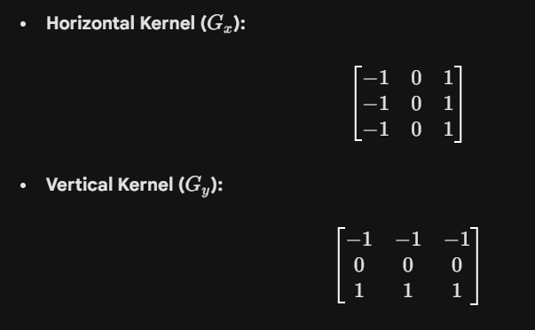
Characteristics:
- Simplicity: It is computationally inexpensive and easy to implement.
- Noise Sensitivity: Because it gives equal weight to all pixels in the neighborhood, it is highly sensitive to image noise. It does not provide any inherent smoothing.

3. The Sobel Operator
The Sobel operator is a modification of the Prewitt operator that introduces a weight of 2 for the center pixels in the mask.
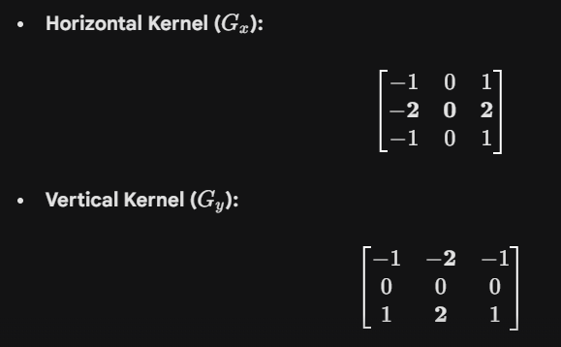

Characteristics:
- Smoothing Effect: The increased weight at the center pixel acts as a small Gaussian-like filter.
- Noise Robustness: This weighting provides an inherent smoothing (low-pass) effect while calculating the derivative. Consequently, Sobel is much better at suppressing noise than Prewitt while still highlighting edges.

4. Key Differences Summary
Feature | Prewitt Operator | Sobel Operator
Weighting | Uses equal weights (1) for all pixels. | Uses a weight of 2 for the center pixels.
Noise Handling | High sensitivity to noise; no smoothing. | Low sensitivity; provides an inherent smoothing effect.
Performance | Faster, but edges may be jagged or noisy. | Slightly more complex, but produces cleaner edges.
Industry Standard | Used in basic, low-resource applications. | Widely preferred in most standard Computer Vision tasks.

Thresholding
- Explain difference between:
- Global thresholding
- Adaptive thresholding

Answer:
1. Global Thresholding
Global thresholding uses a single constant threshold value (T) for the entire image to separate pixels into two classes: foreground (objects) and background.
The Mathematical Logic
For an input image f(x, y), the output binary image g(x, y) is defined as:
g(x, y) = begin{cases} 1 & text{if } f(x, y) > T 0 & text{if } f(x, y) leq T end{cases}
Where T is the global threshold value.
Key Characteristics
- Uniformity: Every pixel in the image is compared against the same T.
- Estimation: The threshold is often determined by analyzing the image histogram. If the histogram is bimodal (two distinct peaks), T is typically chosen as the valley between the peaks.
- Otsu’s Method: This is a popular global algorithm that automatically calculates the optimal T by maximizing the variance between the background and foreground classes.
Advantages & Disadvantages
- Pros: Highly efficient and computationally fast; works perfectly under uniform lighting conditions.
- Cons: Fails significantly if the image has non-uniform illumination (e.g., shadows, gradients of light, or varying reflections).

2. Adaptive (Local) Thresholding
Adaptive thresholding calculates a different threshold for every pixel (or small region) based on the intensity characteristics of its local neighborhood.
The Mathematical Logic
The threshold T(x, y) is a function of the local neighborhood of the pixel at (x, y). The binary image is formed as:
g(x, y) = begin{cases} 1 & text{if } f(x, y) > T(x, y) 0 & text{if } f(x, y) leq T(x, y) end{cases}
Common methods for calculating T(x, y) include:
- Mean of the neighborhood: T is the average intensity of a b * b window minus a constant C.
- Gaussian Weighted Sum: T is a weighted sum of the neighborhood pixels, giving more importance to pixels closer to the center.
Key Characteristics
- Locality: It accounts for spatial variations in lighting across the image plane.
- Robustness: It is highly effective for document scanning or OCR where shadows from the book spine or external light sources create uneven brightness.
Advantages & Disadvantages
- Pros: Handles complex lighting and varying backgrounds exceptionally well.
- Cons: Computationally more expensive than global thresholding; can introduce noise in uniform areas of the image.

Summary Comparison
Feature | Global Thresholding | Adaptive Thresholding
Threshold Value | Single constant T for the whole image. | Different T(x, y) for each pixel/region.
Computation | Fast and simple. | Slower and more complex.
Best Use Case | Controlled lighting, bimodal histograms. | Uneven lighting, shadows, document scanning.
Dependency | Depends on global intensity distribution. | Depends on local pixel neighborhoods.
Example Algorithm | Otsu’s Method. | Mean-C or Gaussian-C Thresholding.

- Why is Otsu thresholding suitable for bimodal histograms?
Answer:

1. The Concept of "Optimal" Separation
A bimodal histogram implies that the image contains two primary classes of pixels. The goal of thresholding is to find a value T that best separates these two distributions.
Otsu’s method is suitable because it treats thresholding as a statistical optimization problem. It searches for the threshold that minimizes the overlap between the two peaks by focusing on the "spread" of the pixel intensities.

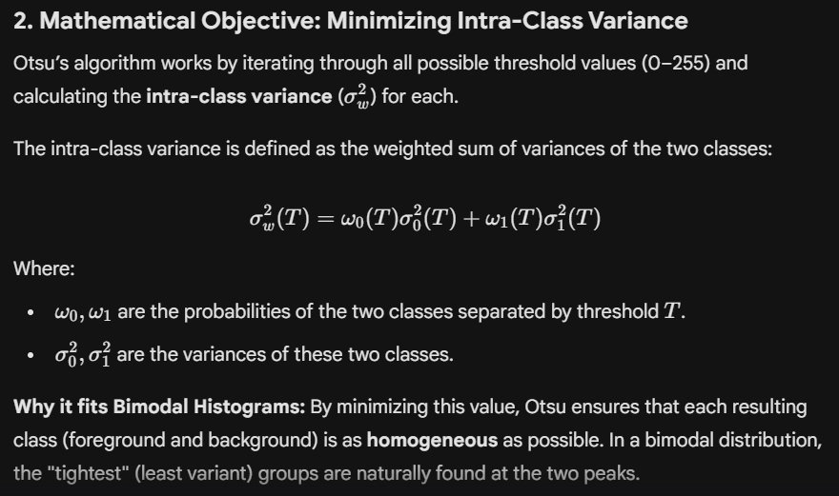

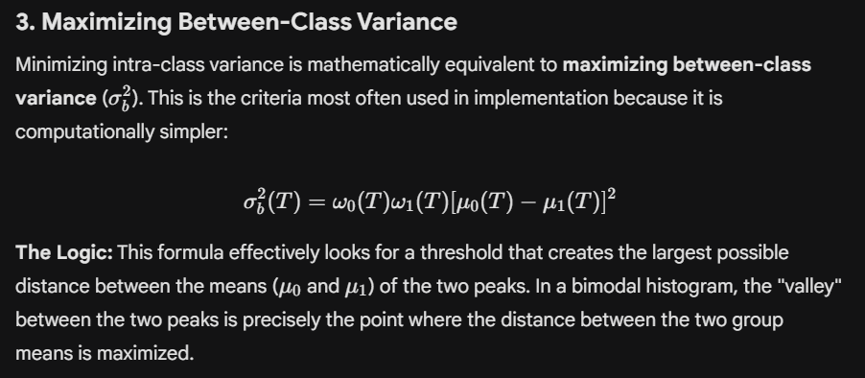

4. Key Advantages for Bimodal Data
- Automatic Selection: Unlike manual thresholding, Otsu does not require human intervention; it "finds" the valley between peaks using pure statistics.
- Parameter-Free: It operates entirely on the global histogram data, making it robust for any image that clearly exhibits two intensity populations.
- Stability: Even if the peaks are of different sizes (e.g., a small object on a large background), the weighting factors (omega_0, omega_1) help maintain an accurate threshold balance.

5. Limitations (When it is NOT suitable)
While perfect for bimodal distributions, Otsu’s method struggles when:
- Noise is high: Noise can create "false peaks" that confuse the variance calculation.
- Unimodal/Non-bimodal Histograms: If there isn't a clear distinction between background and foreground (e.g., a smooth gradient), Otsu will still pick a threshold, but the result will be meaningless.
- Uneven Lighting: Like all global methods, it cannot handle images where one side is significantly darker than the other.

Summary Table
Feature | Otsu’s Rationale
Input Requirement | Best results with Bimodal histograms.
Statistical Goal | Maximize Between-Class Variance.
Operational Logic | Finds the deepest "valley" between the two peaks.
Output | A single Global Threshold value.

Interest Points
- What are keypoints? Why are they important in computer vision?
Answer:

1. What are Keypoints?
Mathematically, a keypoint is a point (x, y) in an image that stands out from its local neighborhood. To be considered a "good" keypoint, a pixel must satisfy these criteria:
- Distinctiveness: The point must have a clear 2D structure. For example, a point in the middle of a flat white wall is a poor keypoint, while the corner of a window is a great keypoint.
- Invariance: The point should be detectable even if the image is rotated, scaled (zoomed), or the lighting changes.
- Repeatability: If you take two different photos of the same scene, the algorithm should be able to find the exact same keypoints in both images.
Common Examples of Keypoint Types:
- Corners: Locations where two edges meet.
- Blobs: Small regions that are significantly brighter or darker than their surroundings.
- T-Junctions: Where one edge ends against another.

2. Why are Keypoints Important?
Keypoints are crucial because they allow a computer to "summarize" an image. Instead of processing millions of pixels, the computer only looks at a few hundred high-value points. Their importance can be categorized into four main areas:
A. Image Matching and Alignment
This is their most common use. By finding identical keypoints in two different images, a system can determine how the images relate to each other.
- Application: Panorama Stitching. The phone identifies keypoints on the edges of two photos and "overlaps" them at those exact points to create a single wide image.
B. Object Recognition
Keypoints act like a "fingerprint" for an object.
- Logic: If a system stores the keypoints of a specific book cover in its memory, it can recognize that book in a messy room by matching the live keypoints to the stored ones.
C. Motion Tracking and Navigation
In robotics and self-driving cars, keypoints are tracked across video frames.
- Logic: If a keypoint on a nearby tree moves from the center of the frame to the left, the computer knows the car is moving forward and slightly to the right. This is the basis of Visual Odometry.
D. 3D Reconstruction (Structure from Motion)
By looking at how keypoints shift between multiple 2D photos taken from different angles, algorithms can calculate the depth and 3D shape of an object.

3. Keypoint Detectors vs. Descriptors
In exams, always clarify that "finding" the point is only half the job:
- Detector: The algorithm that finds the (x, y) coordinates (e.g., Harris Corner, FAST).
- Descriptor: A mathematical vector that describes the "look" of the area around that point (e.g., SIFT, ORB). The descriptor is what actually allows for matching.

Summary Table
Feature | Importance in Computer Vision
Data Reduction | Reduces millions of pixels to a few hundred manageable points.
Robustness | Allows recognition despite changes in scale, rotation, or lighting.
Geometric Basis | Provides the mathematical links needed for 3D mapping and AR.
Efficiency | Enables real-time tracking on mobile devices and robots.

- List the main stages of SIFT algorithm.
Answer:
The Scale-Invariant Feature Transform (SIFT) is a robust algorithm used to detect and describe local features in images. Its primary strength is its ability to find "keypoints" that are invariant to image scaling, rotation, and partially invariant to change in illumination and 3D camera viewpoint.

1. Scale-Space Extrema Detection
This stage identifies potential interest points over all possible scales and locations.
- Scale-Space Creation: The image is repeatedly convolved with Gaussian filters at different scales to produce a set of blurred images.
- Difference of Gaussians (DoG): SIFT calculates the difference between adjacent Gaussian-blurred images. This "Difference of Gaussians" acts as a band-pass filter that highlights blob-like structures (potential keypoints).
- Extrema Search: A pixel is compared to its 26 neighbors in a 3 * 3 region at the current, scale-above, and scale-below levels. If it is a local maximum or minimum, it is selected as a candidate keypoint.

2. Keypoint Localization
Once candidate keypoints are found, they must be refined to ensure stability.
- Sub-pixel Interpolation: The algorithm uses a Taylor series expansion of the scale-space function to determine the precise location and scale of each keypoint.
- Low Contrast Filtering: Keypoints with low contrast (sensitive to noise) are discarded.
- Edge Response Elimination: Points that lie along edges are unstable for tracking. SIFT uses a Hessian matrix to calculate principal curvatures; if the ratio of curvatures is too high, the point is rejected as an edge and only strong "corners" are kept.

3. Orientation Assignment
To achieve rotation invariance, a consistent orientation is assigned to each keypoint based on local image gradient directions.
- Gradient Calculation: For each pixel in a neighborhood around the keypoint, the gradient magnitude and direction are calculated.
- Orientation Histogram: An orientation histogram with 36 bins (covering 360 degrees) is created. Each pixel "votes" into a bin weighted by its gradient magnitude.
- Dominant Direction: The peak in the histogram is assigned as the keypoint's orientation. If there are multiple peaks within 80% of the highest peak, additional keypoints are created at the same location with those different orientations.

4. Keypoint Descriptor Generation
The final stage creates a "fingerprint" for the keypoint so it can be matched across different images.
- Local Grid: A 16 * 16 neighborhood around the keypoint is selected and rotated according to the assigned orientation (ensuring rotation invariance).
- Sub-blocks: This 16 * 16 area is divided into sixteen 4 * 4 sub-blocks.
- Histogram of Gradients: Within each 4 * 4 block, an 8-bin orientation histogram is created.
- 128-Dimensional Vector: With 16 sub-blocks and 8 bins each (16 * 8), a 128-element vector is produced. This vector is normalized to make it invariant to illumination changes (brightness/contrast).

Summary Table
Stage | Main Purpose | Key Technique
1. Extrema Detection | Find potential points at all scales. | Difference of Gaussians (DoG).
2. Localization | Remove unstable/noisy points. | Taylor series & Hessian matrix.
3. Orientation | Achieve rotation invariance. | Gradient orientation histogram.
4. Descriptor | Create a unique matching vector. | 128-dimensional feature vector.

⭐ (Long / Scenario / Numerical)

Scenario-Based Questions
1. Industrial Inspection Scenario
A factory uses computer vision to detect defects on metal surfaces. Images contain noise and uneven illumination.
a) Suggest preprocessing steps.
b) Choose suitable filters.
c) Recommend thresholding method and justify.

a) Suggested Preprocessing Steps
Preprocessing is critical to stabilize the image before feature extraction. For metal surfaces, the following pipeline is recommended:
- Image Grayscale Conversion: Metal surfaces are often monochromatic. Converting to grayscale reduces computational complexity from a 3D tensor to a 2D matrix.
- Illumination Normalization: Since the prompt mentions "uneven illumination," applying a Log Transformation is essential. It maps a narrow range of low-intensity dark values into a wider range, helping to balance the light across the metallic surface.
- Specular Reflection Removal: Highly reflective metal can create "hot spots." Simple clipping or median filtering can help reduce these bright saturated pixels.
- Gamma Correction (gamma < 1): If the factory lighting is too dim, using a Power-Law (Gamma) transformation with gamma < 1 will stretch the dark intensities to make the metal surface details more visible.

b) Suitable Filtering Selection
Given the presence of noise and the need to detect defects (which are essentially edges or textures), a two-stage filtering approach is best:
1. For Noise Reduction: Median Filter or Gaussian Blur
- Median Filter: Metal surfaces often suffer from "salt and pepper" noise due to sensor gain or metallic dust. The Median filter is superior here because it removes noise while preserving the sharp edges of a defect (like a crack or scratch).
- Gaussian Blur: If the noise is Gaussian (random variations), a Gaussian smoothing filter is used to "level" the pixel intensities before edge detection.
2. For Defect Enhancement: Sobel or Laplacian
- Sobel Operator: This is recommended for detecting linear defects like scratches. It uses a weight of 2 on center pixels, providing a smoothing effect that makes it robust against the remaining surface noise.
- Laplacian of Gaussian (LoG): To find "point" defects like pits or holes, a Laplacian filter (high-pass) is used to highlight rapid intensity transitions in all directions.

c) Recommended Thresholding Method & Justification
For industrial metal inspection with uneven illumination, the only reliable choice is Adaptive (Local) Thresholding.
Recommendation: Adaptive Gaussian Thresholding
- Mechanism: Instead of one global T, the algorithm calculates a threshold for every small neighborhood (e.g., 11 * 11 pixels).
- Justification:
  - Handling Uneven Light: In a factory, one side of a metal sheet might be closer to a light source than the other. A Global (Otsu) threshold would treat the darker side entirely as "defect" or "background." Adaptive thresholding adjusts to the local brightness, successfully segmenting the defect regardless of its position on the sheet.
  - Compensating for Surface Texture: Metal has a natural grain. Local thresholding can "ignore" the consistent background texture and focus only on the local anomalies (the defects).
  - Robustness: By using a Gaussian-weighted mean for the local threshold, the system becomes less sensitive to minor surface reflections.

Summary Table
Challenge | Solution | Mathematical Basis
Uneven Illumination | Log/Gamma Transform & Adaptive Threshold | s = c . log(1+r) and T(x,y)
Surface Noise | Median Filter | Non-linear neighborhood ranking
Defect Detection | Sobel Operator | First-order derivatives (G_x, G_y)

2. Medical Imaging Scenario
A doctor wants to enhance dark regions in an X-ray image.
a) Which intensity transformation is best?
b) Explain with formula.
c) Compare with histogram equalization.

In medical imaging, particularly with X-rays, the goal is to improve the visibility of anatomical structures that may be hidden in low-light or low-contrast regions.

a) Best Intensity Transformation: Log Transformation
For enhancing dark regions in an X-ray, the Log Transformation is the most suitable point processing technique.
Justification:
- Dynamic Range Compression: X-ray images often have a very high dynamic range where the intensity values of interest are compressed in the dark (low-intensity) regions.
- Expansion of Dark Pixels: The log function is very steep for low input values and flat for high input values. This mathematically "stretches" the narrow range of dark input pixels into a much wider range of output levels, making subtle details in dense tissue or bone shadows visible to the doctor.

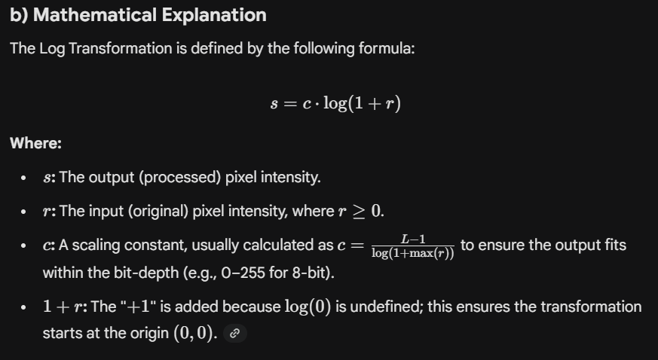

Effect on the Image:
As shown in the transformation curve, a small change in a dark input (r) results in a large change in the output (s). Conversely, large changes in bright input values are compressed into small changes in the output. This effectively "lifts" the details out of the shadows.

c) Comparison with Histogram Equalization
While both techniques improve visibility, they operate on different principles and are used in different medical contexts.
Feature | Log Transformation | Histogram Equalization (HE)
Logic | Fixed mathematical function applied to every pixel. | Statistical redistribution based on the image's Probability Density Function (PDF).
Primary Goal | Specifically targets and expands dark regions. | Increases the global contrast of the entire image.
Data Dependency | Independent of the image's specific histogram. | Entirely dependent on the current distribution of pixels.
Predictability | Very predictable; the transformation curve never changes shape. | Can be unpredictable; may over-enhance noise or create "unnatural" looks in medical scans.
Use Case | Best for X-rays where details are "buried" in dark areas. | Best for "washed out" or low-contrast images where pixels are clustered in the middle.
Final Recommendation for the Doctor:
If the X-ray is generally dark but the structures have a wide range of intensities, the Log Transformation is superior because it preserves the relative relationships of brightness while specifically highlighting the dark anatomy. If the image is simply "gray and blurry" with no clear whites or blacks, Histogram Equalization would be the better choice to stretch the overall contrast.

3. Autonomous Vehicle Scenario
An autonomous vehicle needs reliable edge detection under varying lighting.
a) Compare Sobel, Prewitt, Roberts operators.
b) Which is more robust and why?

For an autonomous vehicle (AV), edge detection is a critical perception task used for lane detection, obstacle avoidance, and sign recognition. Under varying lighting (day, night, shadows), the choice of operator determines the vehicle's ability to distinguish a road boundary from image noise.

a) Comparison of Sobel, Prewitt, and Roberts Operators
All three are gradient-based (first-order derivative) operators that detect edges by finding the maximum change in intensity. They differ in kernel size and the weighting of pixels.
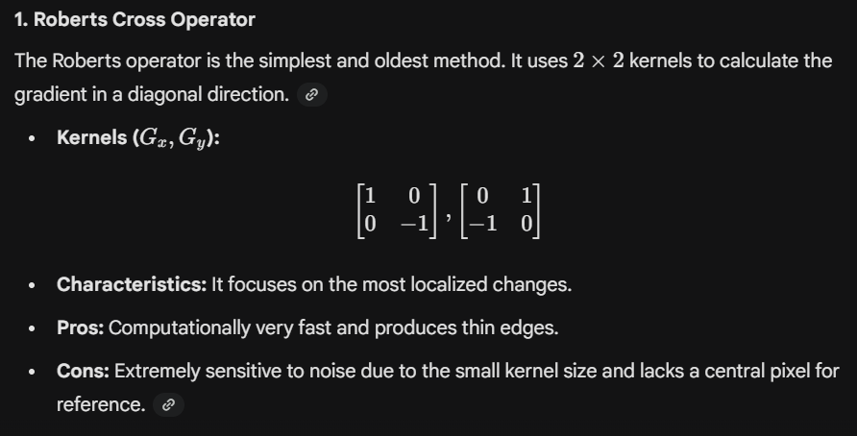
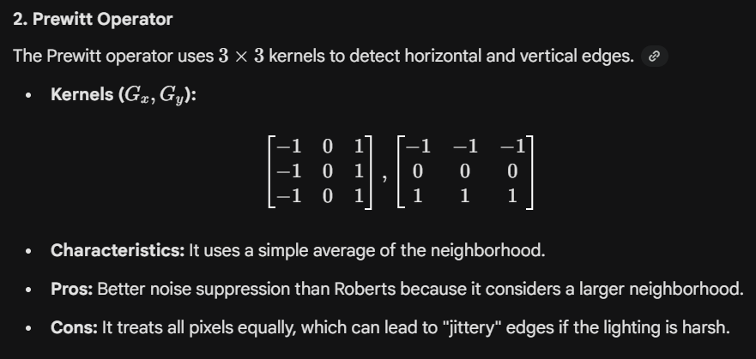

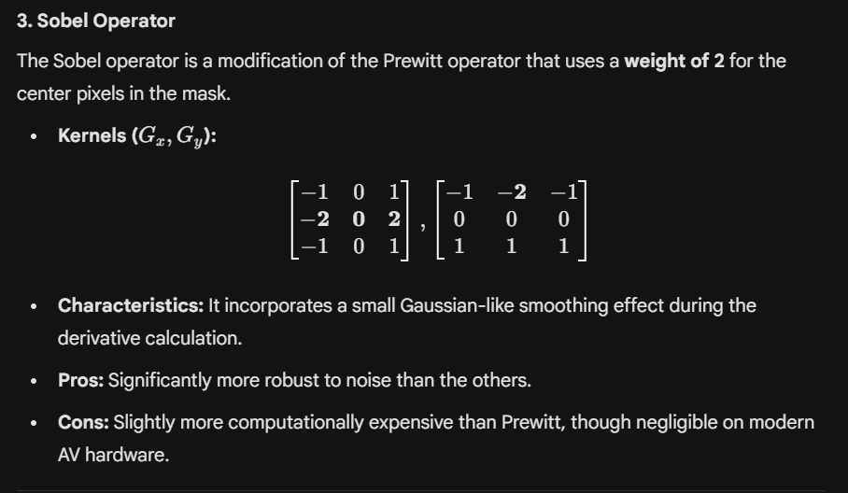

b) Which is More Robust and Why?
For an autonomous vehicle operating under varying lighting, the Sobel Operator is the most robust among these three.
Reasons for Robustness:
- Inherent Smoothing: Varying lighting often introduces "shot noise" or sensor gain noise in dark regions. The Sobel operator's weighted center (2 instead of 1) acts as a low-pass filter. This blurs out minor noise spikes before they can be mistakenly identified as edges (like a fake lane line).
- Central Pixel Importance: In a 3 * 3 grid, the pixel closest to the center is the most statistically relevant to the point being calculated. By giving it more weight, Sobel provides a more accurate gradient approximation than the "flat" weighting of Prewitt.
- Separability: The Sobel kernel is "separable," meaning it can be decomposed into a smoothing vector and a derivative vector. This allows the AV system to perform the operation very efficiently while maintaining high signal-to-noise ratios.
Summary Table for Exam
Feature | Roberts | Prewitt | Sobel (Recommended)
Kernel Size | 2 * 2 | 3 * 3 | 3 * 3
Noise Robustness | Very Low | Moderate | High
Edge Thickness | Very Thin | Moderate | Moderate/Thick
Best Use Case | Real-time, low-power | General-purpose | Perception in AVs

Numerical Problems
4. Image Negation Numerical
Given pixel matrix:
$$\left[\begin{matrix}50 & 120 \\ 200 & 255\end{matrix}\right]$$
Perform image negative transformation.

To perform an image negative transformation on the given pixel matrix, follow these step-by-step instructions.
1. Understanding the Formula
The image negative transformation is a point processing operation where each pixel's intensity is subtracted from the maximum possible intensity level of the image. For an 8-bit image, the total number of intensity levels is L = 256, with values ranging from 0 to 255.
The formula is:
s = (L - 1) - r
Where:
- s: The output (processed) pixel value.
- r: The input (original) pixel value.
- L - 1: The maximum intensity value (255 for 8-bit).
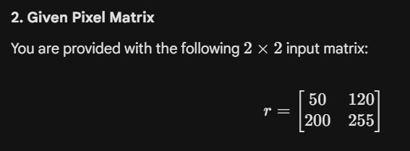
Summary of Results
Original Value (r) | Calculation (255−r) | Negative Value (s)
50 | 255 - 50 | 205
120 | 255 - 120 | 135
200 | 255 - 200 | 55
255 | 255 - 255 | 0

5. Log Transformation Numerical
Given:
$$s=clog⁡(r+1)$$
Let c = 1.
Compute output for r = [0, 10, 50, 200].

To compute the output for a Log Transformation, we use the mathematical relationship between the input pixel intensity and the output intensity. This transformation is a point processing technique used to expand low-intensity (dark) values while compressing high-intensity values.
1. Given Information
- Transformation Formula: s = c log(r + 1)
- Scaling Constant (c): 1
- Input Pixel Values (r): [0, 10, 50, 200]

2. Step-by-Step Calculation
For each input value r, we substitute into the formula s = 1 . log_{10}(r + 1). Note that in digital image processing, base-10 or natural logarithms are commonly used; for these academic exercises, log_{10} is standard.
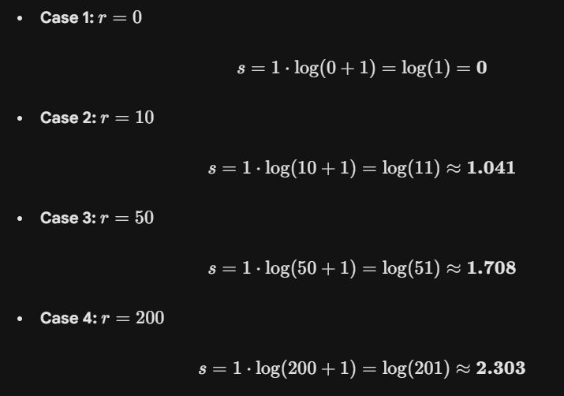
3. Final Output Summary
Input Pixel (r) | Log Calculation (log(r+1)) | Output Intensity (s)
0 | log(1) | 0
10 | log(11) | 1.041
50 | log(51) | 1.708
200 | log(201) | 2.303
4. Analysis of the Result
Notice the non-linear mapping:
- An increase of 10 units at the start (0 to 10) results in an output jump of 1.041.
- An increase of 150 units at the end (50 to 200) only results in an output jump of 0.595.
This demonstrates how the log transformation "stretches" the dark values and "compresses" the bright values, making it highly effective for visualizing details in shadowed regions of an image.

6. Gamma Correction Numerical
Apply gamma transformation:
$$s=r^{0.5}$$
for normalized pixel values:
0.1, 0.4, 0.8
Interpret result.

To solve the Gamma Correction Numerical from your coursework, we follow a step-by-step process of power-law transformation.
1. Given Information
- Transformation Formula: s = r^{gamma}
- Gamma Value (gamma): 0.5
- Normalized Pixel Values (r): [0.1, 0.4, 0.8]
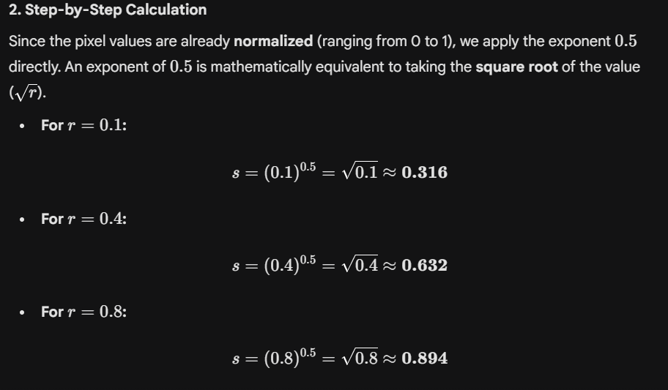
3. Final Output Summary
Input (r) | Calculation (r0.5) | Output (s) | Increase in Intensity
0.1 | (0.1)^{0.5} | 0.316 | +0.216
0.4 | (0.4)^{0.5} | 0.632 | +0.232
0.8 | (0.8)^{0.5} | 0.894 | +0.094
4. Interpretation of Result
- Intensity Enhancement: Since gamma = 0.5 (which is < 1), the output values are significantly higher than the input values. This confirms that the transformation makes the image brighter.
- Dark Region Expansion: The largest relative increase happens at the lower intensities (e.g., 0.1 jumps to over 0.3). This shows that gamma correction with gamma < 1 is ideal for enhancing details in shadowed or dark regions of an image.
- Non-Linearity: The mapping is non-linear, meaning it compresses the highlights (bright areas) while stretching the darks to reveal hidden textures.

7. Histogram Equalization (Concept + Numerical)
Given:
Total pixels = 100.
Histogram:
Level | Count
0 | 10
1 | 20
2 | 30
3 | 40
a) Compute PDF
b) Compute CDF
c) New gray level mapping (L=4)

To compute Histogram Equalization for the provided data, we will follow a systematic process using the given gray level counts.
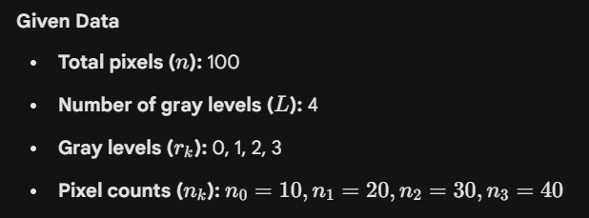
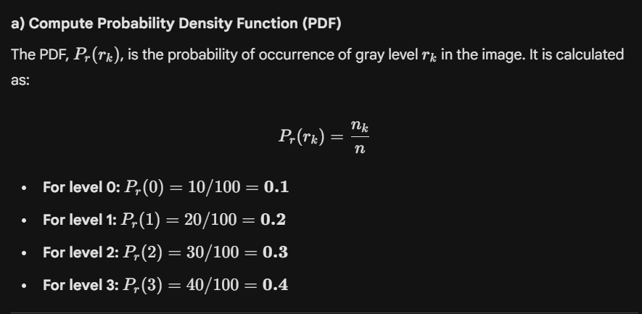
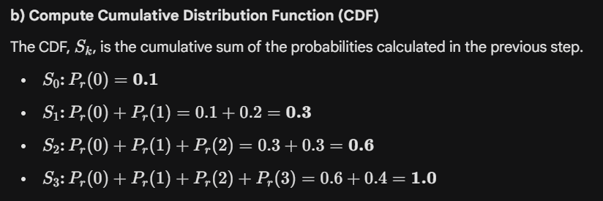



Original Level (rk​) | CDF (Sk​) | Sk​×3 | Rounded (New Mapping)
0 | 0.1 | 0.3 | 0
1 | 0.3 | 0.9 | 1
2 | 0.6 | 1.8 | 2
3 | 1.0 | 3.0 | 3

Summary Table
Gray Level (rk​) | Count (nk​) | PDF | CDF | New Mapped Level
0 | 10 | 0.1 | 0.1 | 0
1 | 20 | 0.2 | 0.3 | 1
2 | 30 | 0.3 | 0.6 | 2
3 | 40 | 0.4 | 1.0 | 3

8. Convolution Numerical
Apply mean filter:
$$\frac{1}{9}\left[\begin{matrix}1 & 1 & 1 \\ 1 & 1 & 1 \\ 1 & 1 & 1\end{matrix}\right]$$
to central pixel of:
$$\left[\begin{matrix}10 & 20 & 30 \\ 40 & 50 & 60 \\ 70 & 80 & 90\end{matrix}\right]$$
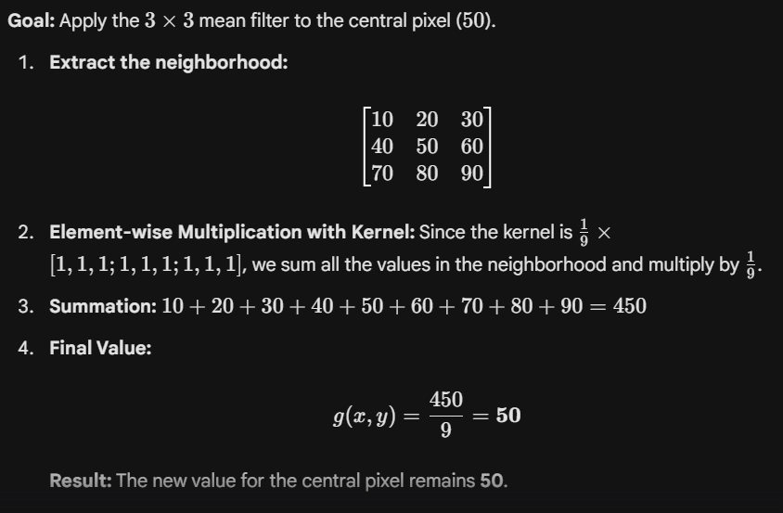

9. Thresholding Scenario
An image contains shadows causing uneven brightness.
a) Global thresholding fails — explain why.
b) Suggest better method.
c) Explain working principle.

In Computer Vision, thresholding is the process of converting a grayscale image into a binary image (black and white) to separate objects of interest from the background. When an image suffers from shadows or uneven illumination, the intensity values are no longer globally consistent, presenting a significant challenge for traditional algorithms.

a) Why Global Thresholding Fails
Global thresholding relies on the assumption that the image has a bimodal histogram where one peak represents the background and the other represents the foreground. It applies a single threshold value (T) to every pixel in the entire image.
The Problem with Shadows:
- Intensity Overlap: In an image with uneven brightness, a "dark" object in a well-lit area might have the same pixel intensity (e.g., 120) as a "light" background in a shadowed area.
- No Clear Valley: The shadow creates a gradient of intensity that fills the "valley" between the background and foreground peaks in the histogram.
- Resulting Failure: If T is set too high, parts of the background in the shadowed area are incorrectly classified as "foreground" (blobs of black). If T is set too low, actual objects in well-lit areas are lost (classified as background).

b) Suggested Method: Adaptive (Local) Thresholding
To overcome uneven illumination, the best approach is Adaptive Thresholding (also known as Local or Dynamic Thresholding).
Unlike global methods, adaptive thresholding calculates a unique threshold value for every pixel based on the intensity characteristics of its immediate neighborhood.

c) Working Principle of Adaptive Thresholding
The core principle of Adaptive Thresholding is that while lighting might vary across the whole image, it is usually relatively uniform within a small local region.
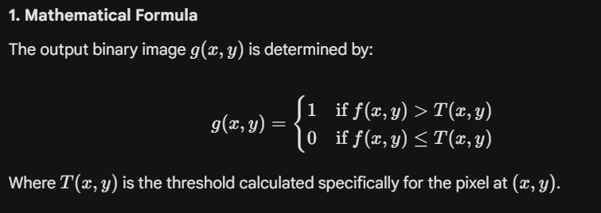

2. Calculation of Local Threshold (T)
There are two common ways to calculate the local threshold:
- Mean-C Method: T(x, y) is the mean intensity of a b * b neighborhood (e.g., 11 * 11 pixels) minus a constant C.
- Gaussian-C Method: T(x, y) is a weighted sum (Gaussian) of the neighborhood intensities minus a constant C. This is often more robust as it gives higher importance to pixels closer to the center.
3. The Process
- A window of size b * b (the Block Size) slides across the image.
- For the pixel at the center of the window, the average brightness of the surrounding pixels is calculated.
- If the pixel is significantly darker than its local neighbors (by more than the constant C), it is marked as foreground (0). Otherwise, it is background (1).
- Because the threshold "adapts" as the window moves into a shadowed area, it successfully detects the object even if the absolute intensity values are much lower.

Summary Comparison
Feature | Global Thresholding | Adaptive Thresholding
Threshold Value | Single constant T for all pixels. | Local T(x, y) for each pixel.
Sensitivity | Highly sensitive to lighting gradients. | Robust against shadows/uneven light.
Computation | Very fast (O(1) per pixel). | Slower (O(text{block size}^2) per pixel).
Best Use Case | Controlled, uniform lighting. | Real-world scenes, scanned documents.

10. Explain SIFT pipeline:
- Scale-space
- Keypoint localization
- Orientation assignment
- Descriptor generation
Discuss why SIFT is scale and rotation invariant.

The Scale-Invariant Feature Transform (SIFT) is a landmark algorithm in computer vision used to detect and describe local features that are highly distinctive and robust to geometric transformations.

I. The SIFT Pipeline
1. Scale-Space Extrema Detection
The goal of this stage is to identify potential interest points that are identifiable from various distances (scales).
- Gaussian Blurring: The input image is repeatedly convolved with Gaussian filters to create a "scale space".
- Difference of Gaussians (DoG): SIFT calculates the difference between adjacent blurred images in the scale-space pyramid. This DoG function efficiently identifies blob-like structures that are potential keypoints.
- Extrema Search: A pixel is compared to its 26 neighbors (8 in the current scale, 9 in the scale above, and 9 in the scale below). If it is a local maximum or minimum, it is marked as a candidate keypoint.
2. Keypoint Localization
Candidate keypoints are refined to discard unstable points.
- Sub-pixel Refinement: The algorithm uses a Taylor series expansion to determine the precise location of the extremum.
- Contrast Thresholding: Points with low contrast (sensitive to noise) are rejected.
- Edge Response Removal: Points that lie along edges are unstable for matching. SIFT uses a Hessian matrix to calculate principal curvatures; points with a high ratio of curvatures (indicating an edge rather than a corner) are eliminated.
3. Orientation Assignment
This stage ensures the descriptor is invariant to image rotation.
- Gradient Calculation: For each pixel in a neighborhood around the keypoint, the gradient magnitude and direction are computed.
- Orientation Histogram: An orientation histogram with 36 bins (representing 360 degrees) is formed. Each pixel "votes" for a bin based on its gradient direction, weighted by its magnitude.
- Dominant Direction: The highest peak in the histogram is assigned as the keypoint’s orientation. If other peaks are within 80% of the maximum, multiple keypoints are created at the same location with different orientations.
4. Descriptor Generation
The final stage creates a unique numerical "fingerprint" for matching.
- Local Grid: A 16 * 16 neighborhood around the keypoint is rotated to align with its assigned orientation.
- Sub-blocks: This area is divided into sixteen 4 * 4 sub-regions.
- 8-Bin Histograms: For each 4 * 4 sub-region, an 8-bin orientation histogram is calculated.
- The 128-D Vector: Concatenating these (16 text{ blocks} * 8 text{ bins}) results in a 128-dimensional vector. This vector is normalized to reduce the effects of illumination changes.

II. Why SIFT is Scale and Rotation Invariant
Scale Invariance
SIFT achieves scale invariance through the Scale-Space Extrema Detection stage. By searching for features across multiple levels of Gaussian blur (the pyramid), the algorithm identifies "blobs" that exist at various resolutions. If an object moves further from the camera, it becomes smaller; however, the SIFT detector will simply find that same feature at a different level of the scale-space pyramid, ensuring the point is still detected.
Rotation Invariance
Rotation invariance is achieved during Orientation Assignment. Because every keypoint is assigned a "dominant orientation" based on local gradients, the Descriptor Generation can be performed relative to that orientation. When the image is rotated, the local gradients rotate with it, and SIFT "re-centers" the coordinate system of the descriptor to match the new angle, resulting in nearly identical 128-bit vectors regardless of the image orientation.

Summary
Stage | Primary Technique | Invariance Provided
Scale-space | Difference of Gaussians (DoG) | Scale Invariance
Localization | Hessian Matrix / Taylor Series | Noise/Edge Robustness
Orientation | Gradient Histograms | Rotation Invariance
Descriptor | 128-D Vector Normalization | Illumination Invariance

